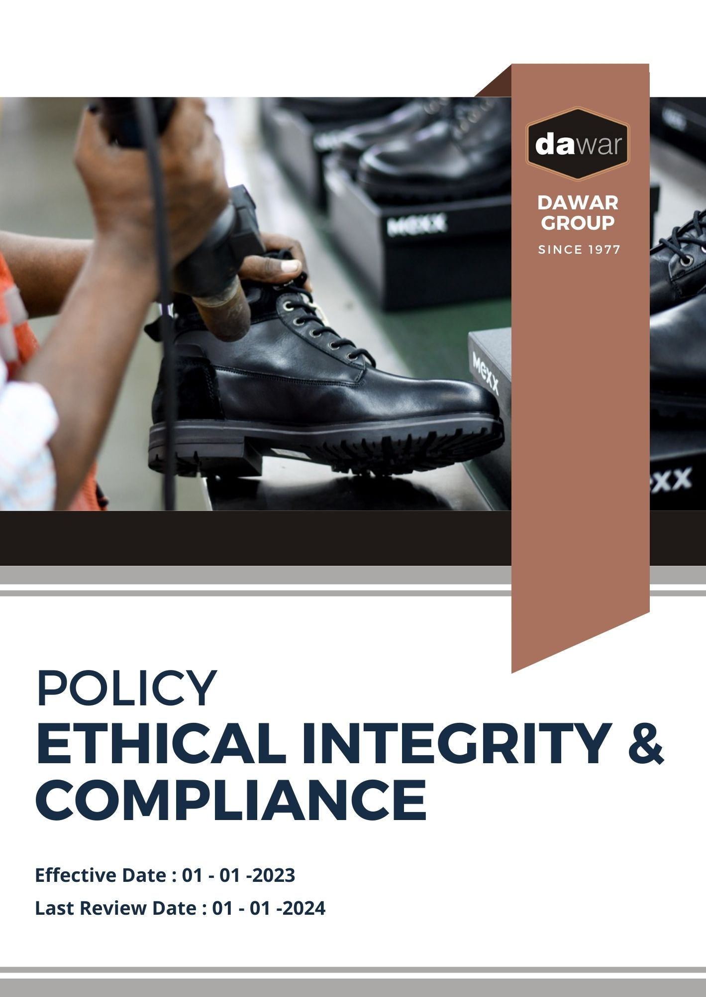

Table Of Contents

A. Why It Matters 3
B. The Dawar Group Approach 3
C. Scope 3
D. What's Expected 3
E. Dawar Group’s Ethical Commitments 4
F. Governance and Allocation of Responsibilities 6
G. Consequences for Violence Violations 6
H. Reporting Section 8
I. Covered SDGs 8
J. Review Mechanism 8
K. Employee Acknowledgement Form: Ethics Policy 9

Why It Matters
Dawar Group is dedicated to maintaining the highest ethical standards in all our business operations. Our commitment to integrity, transparency, and accountability extends across our entire value chain. Ethical practices not only reflect our corporate responsibility but also contribute to long-term business success and strengthen our relationships with customers, stakeholders, and employees.

The Dawar Group Approach
It is the policy of Dawar Group to conduct business ethically, ensuring fairness, transparency, and compliance with all applicable laws and regulations. This includes preventing unethical practices such as bribery, conflicts of interest, financial misconduct, and data breaches. We strive to integrate ethical practices throughout our operations, partnerships, and business dealings.

We set annual ethical goals, develop the necessary capabilities, and allocate resources to promote a culture of honesty and integrity in line with Dawar Group's corporate ethics policy.

Scope
This policy applies to all employees, stakeholders, contractors, partners, customers, contractual workers, and anyone acting on behalf of following sites:

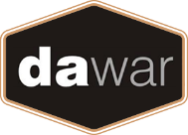 | Dawar Group
 | Address: Near Bapu Asaram Asaram, 12.5 Km, Agra-Delhi Road, Sikandra, Agra-282007 (India)
 | https://www.dawargroup.com/about-us/

What's Expected
- Ethical Compliance
Dawar Group adheres to all applicable laws and ethical standards, fostering a workplace culture that promotes integrity and accountability. We have established performance standards and compliance mechanisms, including:
- Preventing Corruption: We have zero tolerance for bribery, kickbacks, and any form of corrupt practices. Employees are required to avoid and report any instances of improper payments or favors.
- Mitigating Conflicts of Interest: Employees must disclose any personal, financial, or other interests that could improperly influence their business decisions.
- Fraud Prevention: We take proactive steps to detect, investigate, and prevent fraudulent activities across all operations.
- Preventing Financial Misconduct: Money laundering and illicit financial practices are strictly prohibited. We adhere to all anti-money laundering regulations.
- Maintaining Fair Competition: We are committed to fostering healthy competition and prohibiting anti-competitive practices such as price-fixing, bid-rigging, and market division.
- Protecting Information Security: We implement stringent data protection measures to safeguard sensitive information from unauthorized access, breaches, or misuse.
- Promoting Whistleblowing: We encourage employees to report unethical behavior anonymously without fear of retaliation.
- Upholding Human Rights: We respect human rights and ensure fair labor practices across our operations and supply chain.

Dawar Group’s Ethical Commitments
- Establishes 2022 as the Baseline year for measuring progress and achievements in our sustainability initiatives.

- Corruption Prevention:
- We aim to implement a comprehensive anti-bribery training program for 100% of employees by 2026.
- We plan to establish a whistleblower hotline, with 24/7 access for reporting unethical practices by 2026.
- We intend to establish a whistleblower hotline and ensure anonymity and protection for employees reporting corruption incidents, with a goal of resolving 90% of reports within 30 days by 2026

- Conflict of Interest Mitigation:
- We aim to enforce a strict conflict-of-interest policy, ensuring all employees disclose potential conflicts annually, with a target of 100% compliance by 2026.
- We plan to conduct regular conflict-of-interest reviews for senior management and key decision-makers, aiming for a 100% transparency rate by 2026.
- We intend to develop an internal conflict resolution system, resolving 95% of identified conflicts within 60 days by 2026.

- Fraud Detection and Prevention
- We aim to introduce a real-time fraud monitoring system to detect and prevent internal fraud, reducing instances by 20% by 2026.
- We plan to implement mandatory fraud detection training for finance, procurement, and sales teams, covering 100% of relevant employees by 2026.
- We intend to create a cross-functional fraud response team, with a goal of investigating and closing 90% of fraud cases within 45 days by 2026.

- Financial Misconduct Prevention:
- We aim to establish a dedicated Anti-Money Laundering (AML) compliance team to monitor high-risk transactions, achieving full compliance with international AML regulations by 2026.
- We plan to introduce a Know Your Customer (KYC) policy across all departments, ensuring 100% verification of customers and partners by 2026.
- We intend to automate our transaction monitoring systems, aiming to detect and report 100% of suspicious activities within 48 hours by 2026.

- Fair Competition and Anti-Competitive Practices
- We aim to train 100% of sales and procurement teams on anti-competitive practices and fair competition laws by 2026.
- We plan to adopt a zero-tolerance policy towards anti-competitive behavior, auditing all supplier contracts and agreements by 2026 to ensure compliance.
- We intend to implement a supplier engagement program promoting ethical competition, with a target of 80% supplier compliance by 2026.

- Information Security and Privacy
- We aim to achieve 100% compliance with data protection regulations by 2026 through continuous monitoring and employee training on information security.
- We plan to implement a robust cybersecurity framework, reducing data breach incidents by 50% by 2026.
- We intend to conduct annual third-party audits on our information security systems, ensuring transparency and continuous improvement.

- Human Rights and Labor Practices
- We aim to ensure 100% compliance with international human rights standards across our operations and supply chain by 2026.
- We plan to introduce annual human rights training for all employees, achieving 100% participation by 2026.
- We intend to establish a grievance mechanism for labor rights violations, resolving 95% of complaints within 60 days by 2026.

Governance and Allocation of Responsibilities
The governance structure at Dawar Group for the Ethical Conduct Policy ensures clear allocation of responsibilities, driving accountability and continuous progress towards our ethical objectives. Key governance roles include
- Board of Directors:
- Oversees the company’s ethical strategy and ensures alignment with business objectives and stakeholder expectations.

- Ethics Compliance Officer:
- Implements and manages the Ethical Practices Policy.
- Reports on ethics performance and progress towards goals.

- Ethics Committee:
- Monitors daily operations and compliance with ethical standards.
- Coordinates with departments to ensure ethical integrity in every business process.

- Employees:
- Adhere to the policy and participate in ethics training.
- Report any unethical concerns or violations to the Ethics Management Team.

Consequences for Violence Violations

- Disciplinary Actions
- Minor Incidents: Employees involved in non-physical or minor acts of intimidation or harassment may receive verbal or written warnings. Repeated offenses may result in more severe consequences.
- Serious Incidents: Acts of physical violence, severe harassment, or threats will lead to formal disciplinary actions, including suspension or immediate termination of employment.

- Legal Consequences
- Civil and Criminal Liability: Individuals found guilty of engaging in violence or intimidation may face civil or criminal charges, depending on the severity of the incident. Dawar Group will fully cooperate with legal authorities and provide necessary evidence or information.
- Financial Penalties
- Fines and Compensation: Employees or third parties responsible for violence that causes harm or financial loss to the company or its employees may be required to pay fines or compensation for damages.

- Contractual Consequences
- Termination of Contracts: Contractors, suppliers, or partners found to have violated this policy through acts of violence or harassment may have their contracts terminated and will be disqualified from future business with Dawar Group.

- Reporting and Transparency
- Incident Reporting: All incidents of violence will be documented and reviewed, with the outcomes reported internally. In cases of significant violations, Dawar Group reserves the right to disclose the matter publicly to ensure transparency and accountability.

- Rehabilitation and Training
- Mandatory Training: Employees involved in violent or aggressive behaviors may be required to attend mandatory rehabilitation or conflict resolution training, with the goal of preventing future occurrences.

- Remedial Actions
- Corrective Measures: Dawar Group will implement corrective actions to address the root cause of any violence-related incidents. This may include revising workplace safety policies, enhancing reporting mechanisms, or improving conflict resolution processes.

Reporting Section
Dawar Group values transparency in reporting ethical performance, ensuring clear communication with employees, customers, and stakeholders. We monitor our performance through the following mechanisms
- Ethical Performance Metrics:
- Conduct annual evaluations of compliance in areas such as fraud prevention, information security breaches, and corruption.
- Prepare and review monthly reports comparing performance against established baselines.

- Annual Ethics Report:
- Publish an annual report detailing ethical initiatives, challenges, and objectives for the future.
- Engage independent auditors to verify the accuracy of the report.

- Ethical Incident Reporting:
- Implement a robust system for reporting any ethical incidents or violations.
- Provide monthly summaries of reported incidents and corrective actions taken.

- Stakeholder Engagement:
- Document feedback from employees, partners, and customers on ethical issues, using it to drive continuous improvement.

Covered SDGs
 | 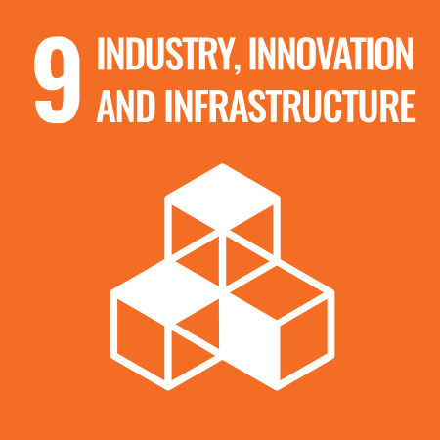 |  | 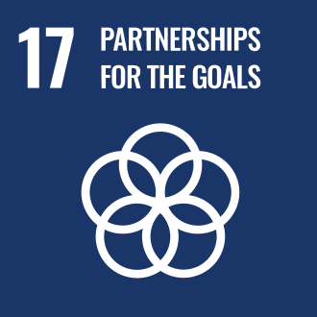

Review Mechanism
The Ethics Compliance Officer is responsible for overseeing the implementation and review of this policy. This policy will be reviewed annually to ensure its effectiveness and relevance. Updates will be communicated to all stakeholders as necessary

(Signature)
Approved By: ____________
Designation: ____________
Next Review Date: 01-01-2025

Employee Acknowledgement Form: Ethics Policy

I acknowledge that I have received, read, and understood Dawar Group's Ethical Conduct Policy. I am aware of the company’s commitment to ethical business practices, including preventing corruption, fraud, conflicts of interest, and upholding information security.

I understand my role in supporting this policy and agree to comply with all ethical standards in my daily work. By signing below, I confirm my commitment to upholding Dawar Group’s ethical principles and contributing to a culture of integrity.

Employee Name: ______________________
Date: _______________
Employee Signature: ____________________

